**Tim Lewis Media Kit**

# Social Media

[TimLewis1207@gmail.com](mailto:TimLewis1207@gmail.com)

<https://www.facebook.com/LewisVentureLLC/>

<https://www.goodreads.com/user/show/148257266-tim-lewis>

<https://amazon.com/author/timothymlewis>

<https://books2read.com/TimLewis>

<https://bsky.app/profile/timlewis.bsky.social>

# Biographies

## ~200 Words

Tim Lewis manages rocket programs by day, and collects hobbies by night. Writing has been the longest running hobby, going back to middle school and first place in a Halloween story contest. He took creative writing at Purdue, but his public works have all been scholastic and technical. In the years following, there has been an accumulation of short stories and scenes brewing that few have seen beyond his laptop. Tim leans toward Sci Fi, Urban Fantasy and Noir, where each contain an element of humor from a life spent as a smart ass. He published his first fiction work, Switch, in 2019 and continues to write and submit as he aspires to his favorite quote by Benjamin Franklin, “If you wou’d not be forgotten / As soon as you are dead and rotten, / Either write things worth reading, / or do things worth the writing.” For more on Tim and his work, go to LewisVenture.com.

## ~100 Words

Tim Lewis manages rocket programs by day, and collects hobbies by night. Writing has been the longest running hobby with an accumulation of short stories and scenes brewing that few have seen beyond his laptop. Tim leans toward Sci Fi, Urban Fantasy and Noir, where each contain an element of humor from a life spent as a smart ass. He published his first fiction work, Switch, in 2019 and has nine short stories published in various anthologies. For more on Tim go to LewisVenture.com.

## ~50 Words

Tim Lewis manages rocket programs by day, and collects hobbies by night. Tim leans toward Sci Fi, Urban Fantasy and Noir, where each contain an element of humor from a life spent as a smart ass. For more on Tim and his work, go to LewisVenture.com.

## 100 Characters

Tim writes Sci Fi and Urban Fantasy, containing an element of humor from life spent as a smart ass.

# Author Headshots

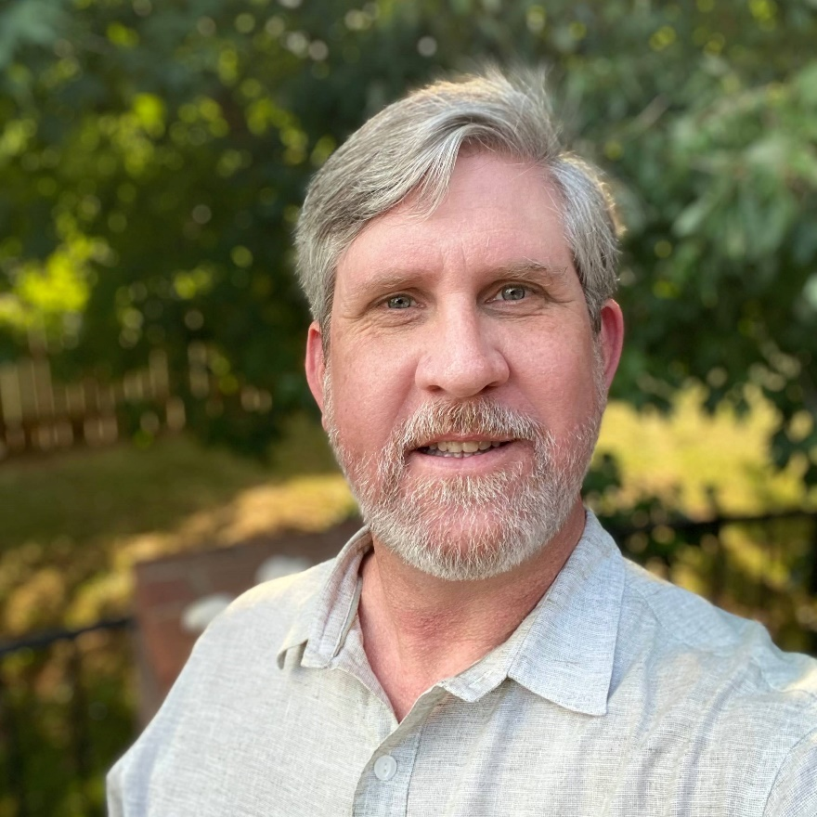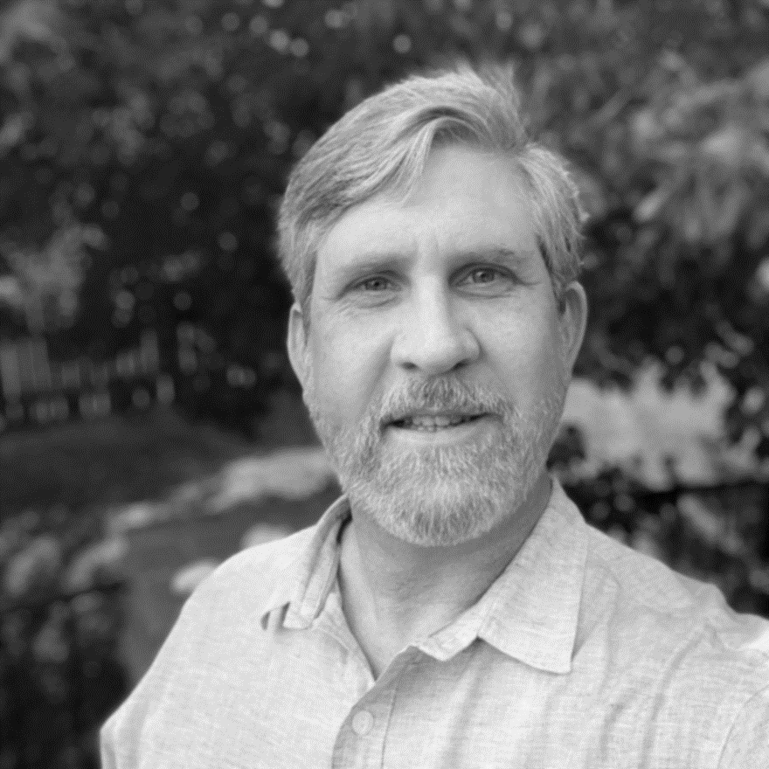

# Bibliography

Engañador - June 2025, Inkd Publishing | Noncorporeal III Nightfall Anthology

Parsec - April 2025. Inked Publishing | Hidden Villains: Criminals Anthology

Glimmer - March 2024, Inked Publishing | Hidden Villains: Betrayed Anthology

Wyrd - April 2024, JordanCon 2024 Anthology | A Magnificent Display of Marvelous Wonders

Adivino - June 2023, Inkd Publishing | Noncorporeal Anthology

Loupers - April 2023, Inkd Publishing | Hidden Villains: Arise Anthology

Accomplice - March 2022, Inkd Publishing | Hidden Villains Anthology

Twelve - April 2022, JordanCon 2022 Anthology | Neither Beginnings Nor Endings

Switch - April 2019, JordanCon 2019 Anthology | So You Want Stories